workSHoP (SHoP Architects exhibition) Study Guide

workSHOP will explore design philosophy, working methods and material uses through firm’s signature projects.

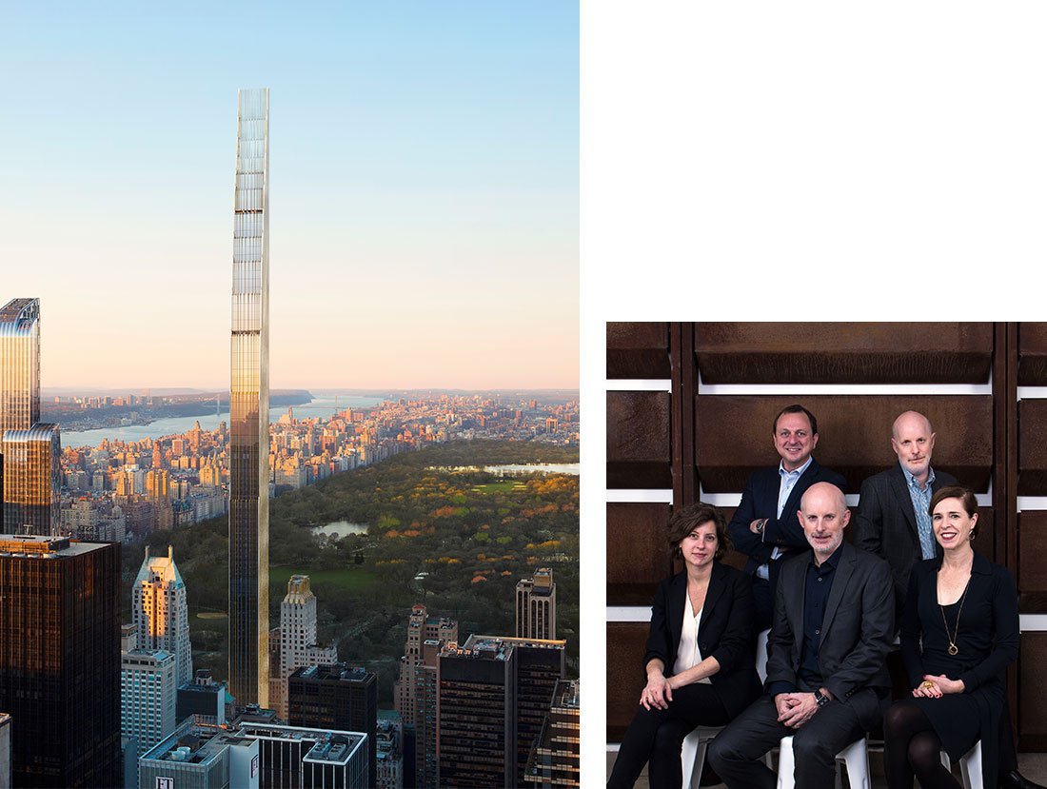

Background:
SHoP is an award-winning architecture firm with a staff of over 180 talented architects, designers and engineers. Located in Lower Manhattan, SHoP was founded in 1996 by five partners Christopher Sharples, Coren Sharples, William Sharples, Kimberly Holden and Greg Pasquarelli. The practice has grown over the past ten years to an office of eighty. Their educational and professional experience encompasses architecture, fine arts, structural engineering, finance and business management. With the exception of single-family residences, SHoP work on many project types, from multi-story housing to academic buildings to master plans. They are currently working on numerous projects totaling $2 billion around the world, and are having a lot of fun doing it. SHoP’s work has won numerous awards, has been published and exhibited internationally, and is in the permanent collection at the Museum of Modern Art.

Recent and current work includes the Barclays Center arena in Brooklyn, Manhattan’s East River Esplanade, the New Academic Building for the Fashion Institute of Technology in New York City, and the Botswana Innovation Hub in Gaborone.

ShoP Philosophy

Fundamental to the SHoP philosophy on architecture, is a belief that a firm can embrace both the conceptual side of design as well as the pragmatic, structural side. SHoP wants to rid the industry of damaging and limiting “isms,” such as postmodernism, deconstructivism, etc. etc, which will create unnecessary boundaries and may potentially lead to the worst “ism” of them all, “specialism.” According to Pasquarelli, a SHoP principal, “we’re the last great generalist profession, the worst thing we could become is specialists.”
SHoP is always concerned about the impact a project will have on the surrounding area. For example: In an article that highlighted the Philippine Coconut building, Greg Pasquarelli says: “[For us], I think it’s very much about how does a building work and what do you want it to do in the city,” he followed with, “it’s using very traditional materials that we see whatever city we’re building in. We look at how that city was made and why they use those local materials. And then we use digital fabrications or the computers making it to make a very contemporary version of that.”

ShoP’s Nine Projects

workSHoP will explore ShoP’s design philosophy, working methods, and approaches to materials through the lens of eight projects that inform and frame SITE’s new building design including:

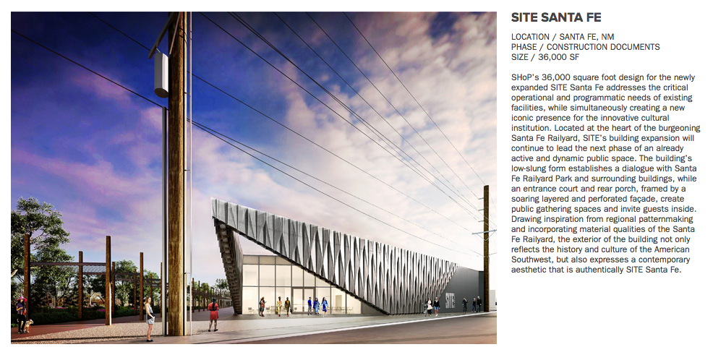

SHoP’s 36,000 square foot design for the newly expanded SITE Santa Fe addresses the critical operational and programmatic needs of existing facilities, while simultaneously creating a new iconic presence for the innovative cultural institution. Located at the heart of the burgeoning Santa Fe Railyard, SITE’s building expansion will continue to lead the next phase of an already active and dynamic public space. The building’s low-slung form establishes a dialogue with Santa Fe Railyard Park and surrounding buildings, while an entrance court and rear porch, framed by a soaring layered and perforated façade, create public gathering spaces and invite guests inside. Drawing inspiration from regional patternmaking and incorporating material qualities of the Santa Fe Railyard, the exterior of the building not only reflects the history and culture of the American Southwest, but also expresses a contemporary aesthetic that is authentically SITE Santa Fe.

workSHop will also feature large-scale plans, material studies, and a Visual Reality experience that will give viewers an immersive preview of SHoP’s design for SITE Santa Fe’s building expansion scheduled for completion in the fall of 2017.
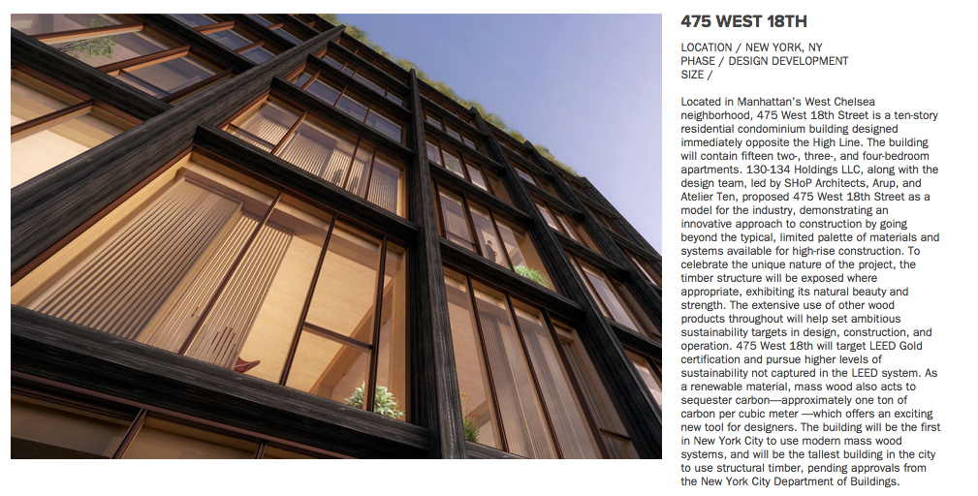
Located in Manhattan’s West Chelsea neighborhood, 475 West 18th Street is a ten-story residential condominium building designed immediately opposite the High Line. The building will contain fifteen two-, three-, and four-bedroom apartments. 130-134 Holdings LLC, along with the design team, led by SHoP Architects, Arup, and Atelier Ten, proposed 475 West 18th Street as a model for the industry, demonstrating an innovative approach to construction by going beyond the typical, limited palette of materials and systems available for high-rise construction. To celebrate the unique nature of the project, the timber structure will be exposed where appropriate, exhibiting its natural beauty and strength. The extensive use of other wood products throughout will help set ambitious sustainability targets in design, construction, and operation. 475 West 18th will target LEED Gold certification and pursue higher levels of sustainability not captured in the LEED system. As a renewable material, mass wood also acts to sequester carbon—approximately one ton of carbon per cubic meter —which offers an exciting new tool for designers. The building will be the first in New York City to use modern mass wood systems, and will be the tallest building in the city to use structural timber, pending approvals from the New York City Department of Buildings.

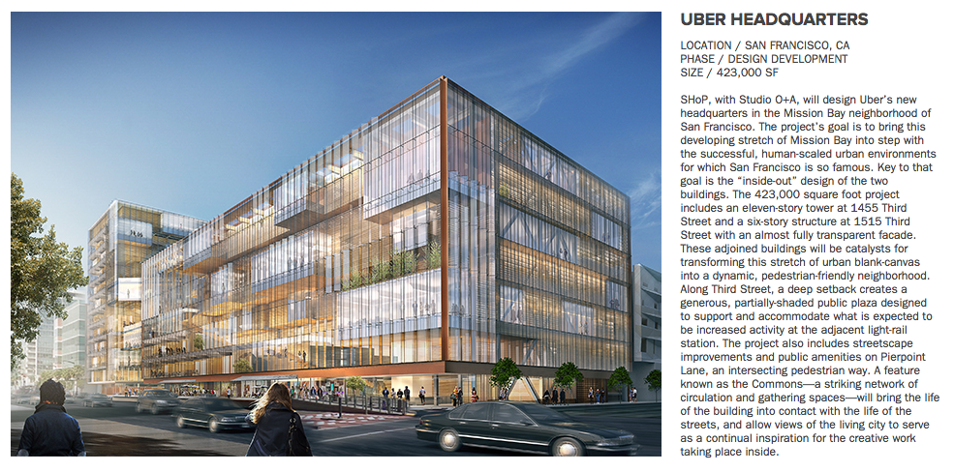
SHoP, with Studio O+A, will design Uber’s new headquarters in the Mission Bay neighborhood of San Francisco. The project’s goal is to bring this developing stretch of Mission Bay into step with the successful, human-scaled urban environments for which San Francisco is so famous. Key to that goal is the “inside-out” design of the two buildings. The 423,000 square foot project includes an eleven-story tower at 1455 Third Street and a six-story structure at 1515 Third Street with an almost fully transparent facade. These adjoined buildings will be catalysts for transforming this stretch of urban blank-canvas into a dynamic, pedestrian-friendly neighborhood. Along Third Street, a deep setback creates a generous, partially-shaded public plaza designed to support and accommodate what is expected to be increased activity at the adjacent light-rail station. The project also includes streetscape improvements and public amenities on Pierpoint Lane, an intersecting pedestrian way. A feature known as the Commons—a striking network of circulation and gathering spaces—will bring the life of the building into contact with the life of the streets, and allow views of the living city to serve as a continual inspiration for the creative work taking place inside.

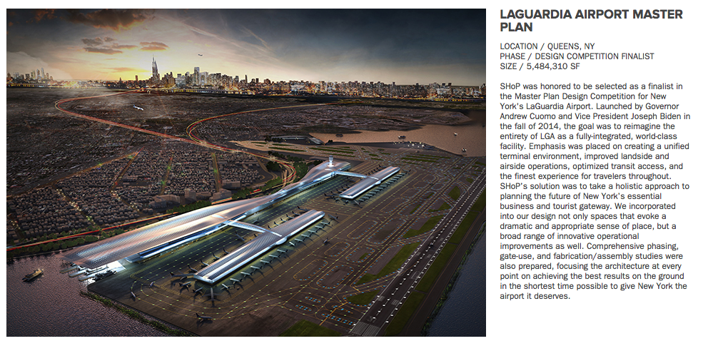

SHoP was honored to be selected as a finalist in the Master Plan Design Competition for New York's LaGuardia Airport. Launched by Governor Andrew Cuomo and Vice President Joseph Biden in the fall of 2014, the goal was to reimagine the entirety of LGA as a fully-integrated, world-class facility. Emphasis was placed on creating a unified terminal environment, improved landside and airside operations, optimized transit access, and the finest experience for travelers throughout. SHoP’s solution was to take a holistic approach to planning the future of New York’s essential business and tourist gateway. We incorporated into our design not only spaces that evoke a dramatic and appropriate sense of place, but a broad range of innovative operational improvements as well. Comprehensive phasing, gate-use, and fabrication/assembly studies were also prepared, focusing the architecture at every point on achieving the best results on the ground in the shortest time possible to give New York the airport it deserves.

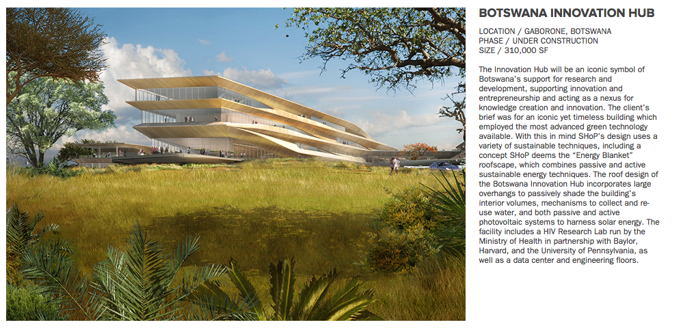
The Innovation Hub will be an iconic symbol of Botswana’s support for research and development, supporting innovation and entrepreneurship and acting as a nexus for knowledge creation and innovation. The client’s brief was for an iconic yet timeless building which employed the most advanced green technology available. With this in mind SHoP’s design uses a variety of sustainable techniques, including a concept SHoP deems the “Energy Blanket” roofscape, which combines passive and active sustainable energy techniques. The roof design of the Botswana Innovation Hub incorporates large overhangs to passively shade the building’s interior volumes, mechanisms to collect and re-use water, and both passive and active photovoltaic systems to harness solar energy. The facility includes a HIV Research Lab run by the Ministry of Health in partnership with Baylor, Harvard, and the University of Pennsylvania, as well as a data center and engineering floors.

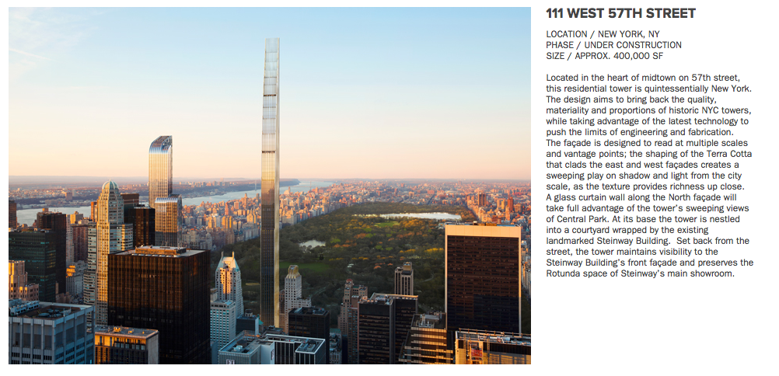

Located in the heart of midtown on 57th street, this residential tower is quintessentially New York. The design aims to bring back the quality, materiality and proportions of historic NYC towers, while taking advantage of the latest technology to push the limits of engineering and fabrication. The façade is designed to read at multiple scales and vantage points; the shaping of the Terra Cotta that clads the east and west façades creates a sweeping play on shadow and light from the city scale, as the texture provides richness up close. A glass curtain wall along the North façade will take full advantage of the tower’s sweeping views of Central Park. At its base the tower is nestled into a courtyard wrapped by the existing landmarked Steinway Building. Set back from the street, the tower maintains visibility to the Steinway Building’s front façade and preserves the Rotunda space of Steinway’s main showroom.

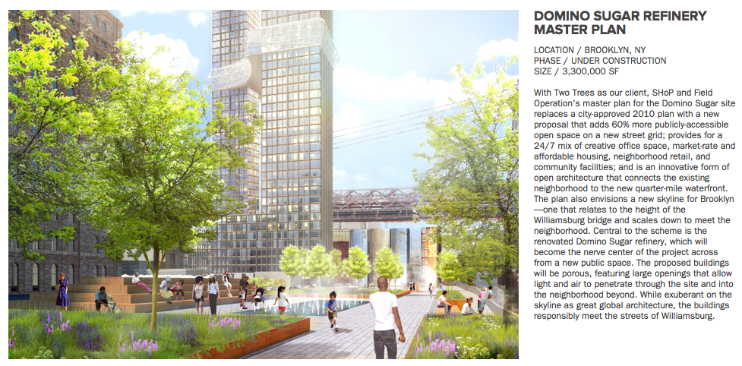
With Two Trees as our client, SHoP and Field Operation's master plan for the Domino Sugar site replaces a city-approved 2010 plan with a new proposal that adds 60% more publicly-accessible open space on a new street grid; provides for a 24/7 mix of creative office space, market-rate and affordable housing, neighborhood retail, and community facilities; and is an innovative form of open architecture that connects the existing neighborhood to the new quarter-mile waterfront. The plan also envisions a new skyline for Brooklyn—one that relates to the height of the Williamsburg bridge and scales down to meet the neighborhood. Central to the scheme is the renovated Domino Sugar refinery, which will become the nerve center of the project across from a new public space. The proposed buildings will be porous, featuring large openings that allow light and air to penetrate through the site and into the neighborhood beyond. While exuberant on the skyline as great global architecture, the buildings responsibly meet the streets of Williamsburg.

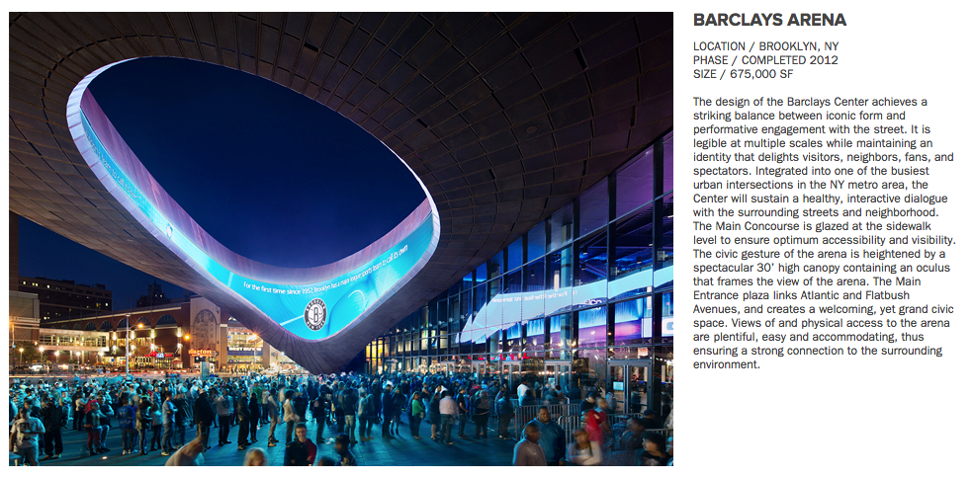
The design of the Barclays Center achieves a striking balance between iconic form and performative engagement with the street. It is legible at multiple scales while maintaining an identity that delights visitors, neighbors, fans, and spectators. Integrated into one of the busiest urban intersections in the NY metro area, the Center will sustain a healthy, interactive dialogue with the surrounding streets and neighborhood. The Main Concourse is glazed at the sidewalk level to ensure optimum accessibility and visibility. The civic gesture of the arena is heightened by a spectacular 30’ high canopy containing an oculus that frames the view of the arena. The Main Entrance plaza links Atlantic and Flatbush Avenues, and creates a welcoming, yet grand civic space. Views of and physical access to the arena are plentiful, easy and accommodating, thus ensuring a strong connection to the surrounding environment.

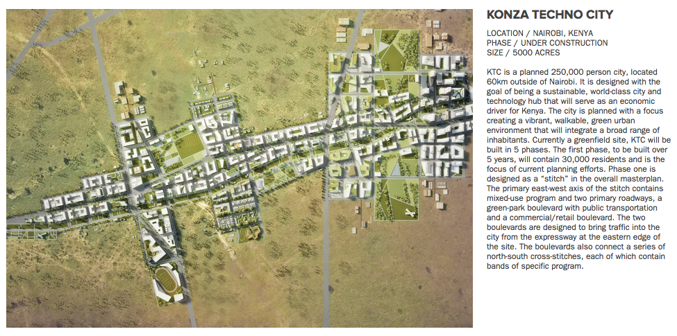
KTC is a planned 250,000 person city, located 60km outside of Nairobi. It is designed with the goal of being a sustainable, world-class city and technology hub that will serve as an economic driver for Kenya. The city is planned with a focus creating a vibrant, walkable, green urban environment that will integrate a broad range of inhabitants. Currently a greenfield site, KTC will be built in 5 phases. The first phase, to be built over 5 years, will contain 30,000 residents and is the focus of current planning efforts. Phase one is designed as a “stitch” in the overall masterplan. The primary east-west axis of the stitch contains mixed-use program and two primary roadways, a green-park boulevard with public transportation and a commercial/retail boulevard. The two boulevards are designed to bring traffic into the city from the expressway at the eastern edge of the site. The boulevards also connect a series of north-south cross-stitches, each of which contain bands of specific program.

