Wangechi Mutu

Born: 1972
Hometown: Nairobi, Kenya
Lives and Works: New York, NY
Website: wangechimutu.com
Twitter: @WangechiMutu
Education: MFA, Sculpture, Yale University, New Haven, CT, 2000
BFA, Cooper Union for the Advancement of the Arts and Science, New York, NY, 1996
I.B., United World College of the Atlantic, Wales, England, 1991
Loreto Convent Msongari, Nairobi, Kenya, 1989
Wangechi Mutu Biography

Kenyan-born Wangechi Mutu is a Brooklyn-based artist whose sculptures, works on paper, installations, and videos explore gender, race, and sexual identity using collage and assemblage strategies that create provocative juxtapositions of the female body.
Her collages are constructed using fragments from fashion and travel magazines, pornography, African art books, automotive schematics, and images drawn from science fiction as well as hand-drawn or painted elements, which create a variety of new formations of the body. Photo-based collage elements are often intermixed with decorative or abstract patterns, which create a simultaneous feeling of familiarity and other-worldliness to the works.

Mutu’s figures are equally repulsive and attractive. From corruption and violence, Mutu creates a glamorous beauty. Her figures are empowered by their survivalist adaptation to atrocity, immunised and ‘improved’ by horror and victimisation. Their exaggerated features are appropriated from lifestyle magazines and constructed from festive materials such as fairy dust and fun fur. Mutu uses materials which refer to African identity and political strife: dazzling black glitter symbolises western desire which simultaneously alludes to the illegal diamond trade and its terrible consequences. Her work embodies a notion of identity crisis, where origin and ownership of cultural signifiers becomes an unsettling and dubious terrain.

Mutu’s collages seem both ancient and futuristic. Her figures aspire to a super-race, by-products of an imposed evolution. In this series of work, she uses old medical diagrams, to convey the authenticity of artefact, as well as an appointed cultural value. Satirically identifying her ‘diseases’ as a sub/post-human monsters, she invents an equally primitive and prophetically alien species; a visionary futurism inclusive of cultural difference and self-determination.

ART

Nasher Museum of Art at Duke University
Source: http://nasher.duke.edu/mutu/art.php
Saatchi Gallery
Source: http://www.saatchigallery.com/artists/wangechi_mutu.htm

Gladstone Gallery
Source: http://www.gladstonegallery.com/artist/wangechi-mutu/work#&panel1-4

Galleries
Barbara Gladstone Gallery, New York, NY
Susanne Vielmetter Los Angeles Projects, Los Angeles, CA
Victoria Miro, London, England

Wangechi Mutu Permanent Collections
Select Permanent Collections
MoMA, The Museum of Modern Art, New York, NY
Musee d'art Contemporain de Montreal, Montreal, Quebec, Canada
Museum of Contemporary Art, Chicago, IL
Museum of Contemporary Art, Los Angeles, CA
New Museum of Contemporary Art, The Altoids Collection, New York, NY
Princeton University Art Museum, Princeton, NJ
San Francisco Museum of Modern Art, San Francisco, CA
The Museum of Modern Art, Judith Rothschild Foundation, New York, NY
The Saatchi Collection, London, England
The Studio Museum In Harlem, New York, NY

Source: http://www.artspace.com/wangechi_mutu

And http://rogallery.com/Mutu_Wangechi/mutu-biography.html

Interviews and Mentions

Art 21 Magazine
http://blog.art21.org/2011/02/25/wangechi-mutu/

Bomb Magazine Interview
http://bombmagazine.org/article/1000052/wangechi-mutu

SITE Exhibitions

Then: In 2006 Wangechi Mutu’s work as featured in SITE Santa Fe’s Sixth International Biennial: Still Points of Turning World, curated by Klaus Ottmann.
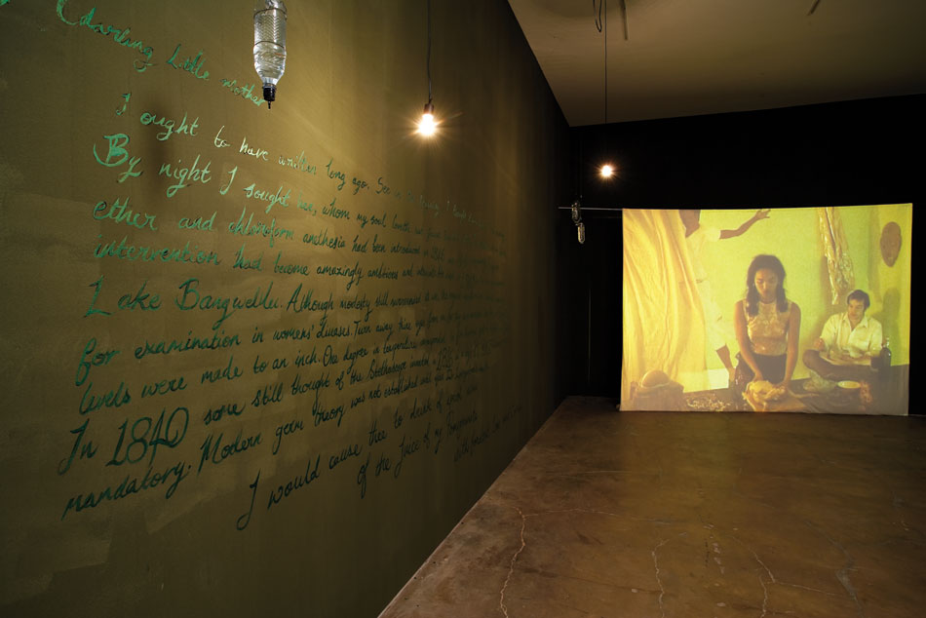

For Spring 20/20, Mutu will collaborate with artist Edgar Arceneaux on a site-specific drawing installation. The artists will be in residence at SITE in early March leading up to the exhibition opening as they create this collaborative work.

For Spring 20/20, Mutu will provide an eight minute animated video, titled The End of Eating Everything, no further information about the video has been provided just yet.

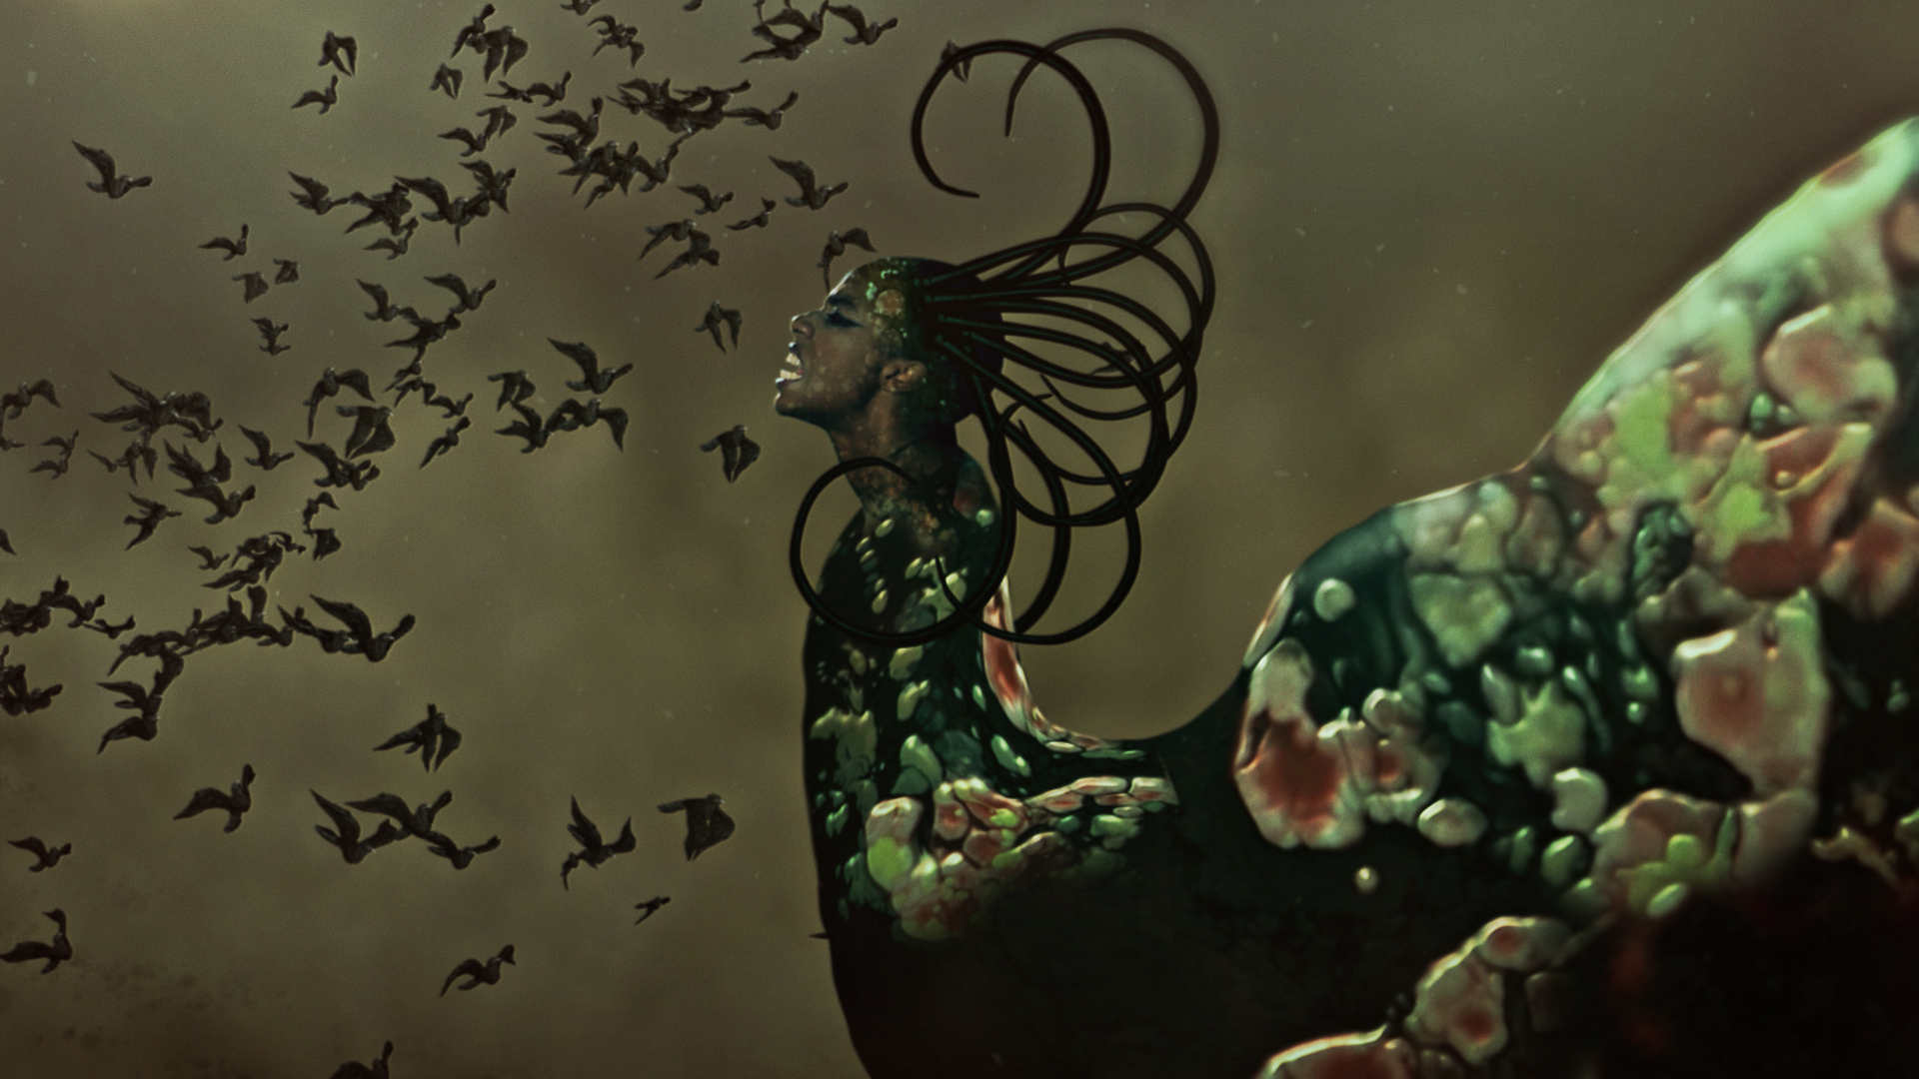

Mutu will also collaborate with Edgar Arceneaux, which will be a SITE specific installation drawing, with a nebulus cloud feel as well as sculptural aspects. Sculptural elements include red lingerie scrunched into ball shapes, banded with string or rubber band/rope/knotting. Sculptural elements will be embedded into the wall/drawing, like wounds. Creation of the drawing will be documented with time lapse-GO PRO.
