Terry Allen

Short Biography

Terry Allen was born in Wichita, Kansas in 1943 and raised in Lubbock, Texas. Influenced by country western music and rock and roll, Allen knew from an early age that he wanted to work in the arts and in the mid-1960s traveled to Los Angeles to study at Chouinard Art Institute where he earned his BFA.

He then developed a storyline and cast of characters that morphed into a major body of visual art including musical and theatrical performances, sculpture, painting, drawing, video, and installations. Allen’s multimedia windows into the human condition have won him a Guggenheim Fellowship and three grants from the National Endowment for the Arts.

The artist’s public works can be found in unconventional places – from Los Angeles’s Citicorp Plaza, to San Francisco’s Moscone Center, to the Museum of Modern Art in New York. The artist currently resides in Santa Fe, New Mexico with his wife, Jo Harvey.

Source: http://www.crala.org/internet-site/Other/Art_Program/artist_list/terry_allen.cfm

Extended Biography

Terry Allen is a visual artist and songwriter who was raised in Lubbock, Texas. He graduated from Chouinard Art Inst. in Los Angeles and has worked as an artist & musician since 1966. He has received numerous awards and honors including a Guggenheim Fellowship and National Endowment for the Art Fellowships; Awards for the Visual Arts (AVA), Washington D.C.; Bessie (New York) and Isadora Duncan (San Francisco) Critic Awards for text, music, sets, costumes for PEDAL STEAL (Margaret Jenkins Dance Co.); AICA Award 2004, 2nd place (International Association of Art Critics) for Best Show in Commerical Gallery, for DUGOUT I, LA Louver Gallery, Venice, CA, curated by Peter Goulds; Induction into the Buddy Holly Walk of Fame in 1992; United States Artists Oliver Fellow, 2009.
His work has been shown throughout the United States and Inter-nationally, including Documenta and San Paolo, Paris, Sydney & Whitney Biennales and is represented in major private and public collections, including the Metropolitan Museum of Art and The Museum of Modern Art in New York, Hirshhorn Museum in Washington DC, The Museum of Contemporary Art (MOCA) and L.A. County Museum of Art in Los Angeles, Museum of Contemporary Art, San Diego (MCASD) and Houston & Dallas Museums of Fine Art. His numerous public commissions can be found in such places as L.A.'s Citi-Corps Plaza, San Francisco Moscone Center, The Stuart Collection at UCSD in La Jolla, CA, Oliver Ranch in Sonoma, CA and Denver, Houston and Dallas/Ft. Worth Intercontinental airports. His book & theater piece DUGOUT was published in 2005 by Univ. of Texas Press and an extensive monograph TERRY ALLEN of Allen's work was published in 2010, also Univ. Texas Press, with essays by Dave Hickey, Marcia Tucker and Michael Ventura.
He has written for and worked in both radio and theater. Some of his selected staged works include JUAREZ(A SIMPLE STORY), THE EMBRACE...ADVANCED TO FURY, ANTI-RABBIT BLEEDER, WARBOY (AND THE BACKBOARD BLUES), GHOST SHIP RODEZ which he wrote and directed; PIONEER, set design, co-written with Jo Harvey Allen & Rende Eckert, directed by Robert Woodruff, Paul Dresser Production, performed throughout USA; LEON AND LENA (and Lentz), composer, directed by JoAnne Akalaitis, Guthrie Theater, Minneapolis, MN; CHIPPY, Diaries of a West Texas Hooker, set & costume design, co-written with Jo Harvey Allen, music co-written with Joe Ely, Butch Hancock, directed by Evan Yianoulis, co-produced by American Music Theater Festival, Philadelphia, PA & Lincoln Center's 'Serious Fun' series, New York, NY.
Allen has recorded 12 albums of original songs, including classics JUAREZ and LUBBOCK (on everything), and his most recent BOTTOM OF THE WORLD.His songs have been recorded by such diverse artists as: Bobby Bare, Guy Clark, Little Feat, Robert Earl Keen, David Byrne, Colin Gilmore, Doug Sahm, Ricky Nelson, Cracker, and Lucinda Williams. He has written numerous songs for film and theater, including the music soundtrack for Jane Anderson's Showtime Emmy nominated THE BABY DANCE. He has been described by critic Dave Hickey in the Los Angeles Times as "a true modern day renaissance man...renowned for his effortless command and outrageous combination of disparate genres and media, according to the task at hand." Terry Allen lives and works in Santa Fe, New Mexico, with his wife, actress and writer, Jo Harvey Allen.

Source: http://www.terryallenartmusic.com/biography.php

Art Reviews

Vietnam Comes Home : Terry Allen's 'Youth in Asia' Confronts Veterans' Battle
Source: http://articles.latimes.com/1993-07-17/entertainment/ca-13828_1_terry-allen

Publications

Dugout, University of Texas Press, 2005
Source: http://utpress.utexas.edu/index.php/books/alldug

Terry Allen, New Monograph, University of Texas Press, May 2010

Source: http://utpress.utexas.edu/index.php/books/allter

ART

Gallery Paule Anglim, San Francisco, CA
Source: http://www.gallerypauleanglim.com/Gallery_Paule_Anglim/Allen.html

Holly Johnson Gallery, Dallas, TX
Souce: http://www.gallerypauleanglim.com/Gallery_Paule_Anglim/Allen.html

Flatbed Press & Gallery
Source: http://www.gallerypauleanglim.com/Gallery_Paule_Anglim/Allen.html

Moody Gallery, Houston, TX
Source: http://www.moodygallery.com/Artists/Allen/Terry.html

SITE Exhibitions

One on One: A Suite of Solo Shows

One on One compiles a diverse range of mediums, including video, painting, drawing, installation, and computer dialogue, to engender a unique exploration of the social, the psychological, and the personal through the individual.

Each of the five artists in One on One profoundly examines the life of one person. The goal of each examination is different, as are the means and the findings. But in each case, the artists use their subjects as mirrors, not only for themselves, but also for the viewers. We are drawn into the intimacy of the exchange and face different aspects of ourselves in the artists and their subjects.

For One on One, Terry Allen examined an episode in the life of the artist Antonin Artaud. Throughout his life, Artaud suffered a number of psychological crises, resulting in his repeated and lengthy institutionalization. In 1937, Artaud went to Ireland to return to the Irish people what he believed was the staff of St. George. He was involved in an altercation with the Dublin police and was subsequently deported. Because of his deteriorating psychological state, he was chained to a cot in the hull of the ship Washington for the journey back to France. This journey serves as the inspiration for Allen’s Ghost Ship Rodez, a music theatre piece starring Jo Harvey Allen, which was shown at the Lensic the 9th of April in 2010.

Allen’s presentation in One on One Exhibition

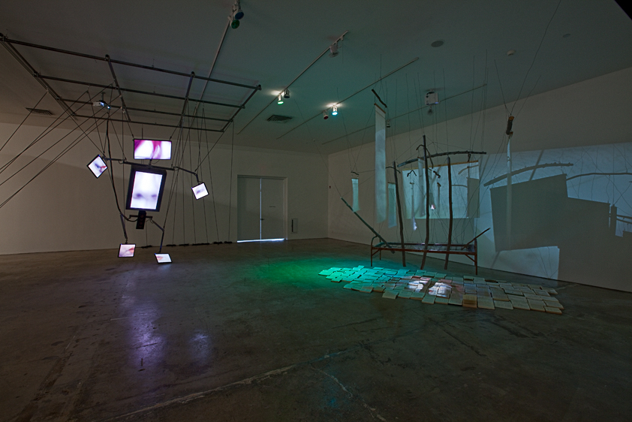

Allen’s One on One exhibition consisted of room-sized multimedia works blending sculpture and video. A portion of the exhibition invoked the physical environment of the Washington. Another included a larger-than-life-size figure Momo lo Mismo, that refers to Artaud and the “Daughter of the Heart to be Born,” an archetype representing all the women in Artaud’s life.
Although these works allude to the physical realities of Artaud’s life, their video components explore Artaud’s mindscape, giving form to psychological space.
In addition, Allen presented a large suite of works on paper entitled The Momo Chronicles, loosely based on Artaud’s 1936 journey to Mexico to partake in the ceremonies of the Tarahumara Indians.
Allen invited us to take a journey into the depths of Artaud’s mind as he sees it — a place where the boundaries of time and space are broken, where the past and future come together in the present.

Source: https://sitesantafe.org/exhibition/one-on-one/

SPRING 2016 20 Years/20 Shows Exhibition

For SITE’s Spring 20/20 Show, Allen will present a new immersive narrative video and sound installation entitled Memwars. In this new work, video projections of a script being read will move slowly along tracks on the wall to create a destabilizing and ever-changing experience of cinema and storytelling.

