Edgar Arceneaux

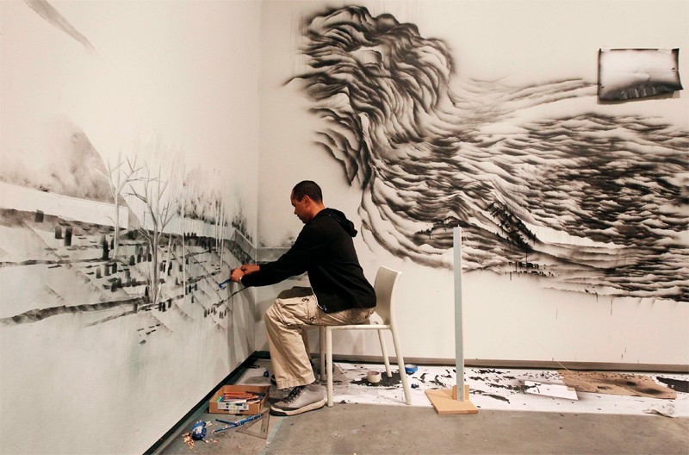

Biography

Edgar Arceneaux, born and raised in Los Angeles where he currently resides is an installation artist, whose drawings, sculptures, installations, and films have been extensively presented by museums and galleries in the United States and Europe. Edgar is known for his work that covers a range of subjects, including philosophy and identity. He has had solo exhibitions at Kunstverein Ulm, Germany; Galerie Kamm, Berlin; Frehrkring Wiesehoefer, Cologne; Susanne Vielmetter Los Angeles Projects; Studio Museum, Harlem, New York; and Project, New York. He has also contributed to a few group shows, which include True Stories at the Witte de With, Rotterdam; Social Strategies: Redining Social Realism at University Art Museum, Santa Barbara, Urban Aesthetics at African American Museum of Art, Los Angeles, and One Planet Under a Groove at Bronx Museum, New York. He is the current executive director of Watts House Project, a non-profit organization, which focuses on renovating residential properties and providing programs and venues for community involvement in the neighborhood around the historic Watts Tower. He has also received his BFA from Art Center College of Design in Pasadena, California and an MFA from California Institute of Arts in Valencia, California. He has also studies at Skowhegan School of Painting and Sculpture in Maine as well as the Fachhochschule Aachen in Germany. He was also named a U.S. Artists Fellow in 2007, and was included in the 2008 Whitney Biennial.

Arceneaux Timeline

1972
Born in Los Angeles. Lives and works in Los Angeles

1996
BFA, Art Center College of Design, Pasadena, CA.

1998
The Banff Center for the Arts, Banff, Alberta, Canada

1998
Project Row Houses, Houston, Texas

1999
Skowhegan School of Painting Skowhegan, Maine

2000–2001
Fachhochschule Aachen, Aachen, Germany

2001
MFA, California Institute of the Arts, Valencia, CA

2005
Joyce Award, Chicago

2005
Creative Capital, New York

2005
William H. Johnson Foundation Grant, Los Angeles

2006
ArtPace Residency, San Antonio, TX

2007
United States Artists Fellowship

SITE Exhibition

Edgar Arceneaux will collaborate with artist Wangechi Mutu on a site-specific drawing installation. The installation will have a nebulus cloud feel as well as sculptural aspects. Sculptural elements include red lingerie scrunched into ball shapes, banded with string or rubber band/rope/knotting. Sculptural elements will be embedded into the wall/drawing, like wounds. Creation of the drawing will be documented with time lapse-GO PRO.

