Luis Camnitzer

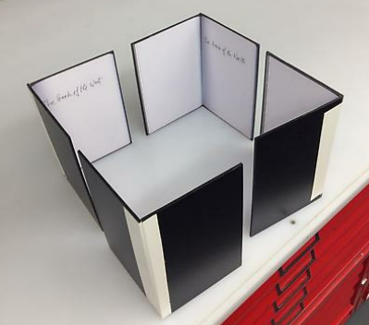

Short bio

- Artist, critic, educator, and theorist, Luis Camnitzer was born in Germany and moved to Uruguay when he was a year old.
- In 1964, he founded the New York Graphic Workshop with artists Liliana Porter and José Guillermo Castillo.
- In 1971 helped establish New York’s Museo Latinoamericano, and a splinter group, Movimiento de Independencia Cultural de Latino América (MICLA). Camnitzer’s installation Art History Lesson no.6 (2000) is made up of ten slide projectors ranged around the gallery space, each one casting an empty rectangle of light onto the wall. The Uruguayan artist’s work underscores the fact that art history is written by those in power, and tends to exclude certain accounts.

Source: http://www.guggenheim.org/guggenheim-foundation/collaborations/map/latinamerica/artist/luis-camnitzer

Biography

- Luis Camnitzer (b.1937) is a German-born Uruguayan artist and writer who moved to New York in 1964. He was at the vanguard of 1960s Conceptualism, working primarily in printmaking, sculpture, and installations.
- Camnitzer’s artwork explores subjects such as social injustice, repression, and institutional critique. His humorous, biting, and often politically charged use of language as art medium has distinguished his practice for over four decades.
- In 1964 he co-founded The New York Graphic Workshop, along with fellow artists, Argentine Liliana Porter and Venezuelan Guillermo Castillo (1941–1999). For six years until the end of the workshop in 1970, they examined the conceptual meaning behind printmaking, and sought to test and expand the definition of the medium.
- During the late 1960s and early 1970s, Camnitzer developed a body of work that explored language as primary medium, shifting from printing text on paper or walls, such as his Dictionary etchings and the room-size installation, Living Room (both 1969).
- As his interest in language unfolded, so did his aim to identify socio-political problems through his art. Camnitzer responded in great part to the growing wave of Latin American military regimes taking root in the late '60s, but his work also points to the dynamic political landscape of his adopted country, the United States.
During the 1970s, Camnitzer created a key body of work that blended both language and humor—producing a series of object-boxes that placed ordinary items within wood-framed glass boxes with text printed on brass plaques. In all cases, the printed sentences are also the works’ titles.
- In many ways, these boxes anticipate one of Camnitzer’s most important works, the Uruguayan Torture Series (1983–84). This photo-etching series epitomizes Camnitzer’s ability to question the social and political roles of an individual in society, while also examining a dimension of human psychology by pairing images and text to create new meaning.
- Though Camnitzer never left New York, his practice remains intrinsically connected to his homeland and the whole of Latin America.
- This consistent dedication cements his place as a key figure in shaping debates around ideas of post-Colonialism, Conceptualism, and pedagogy.
- Camnitzer’s work has been shown at important institutions since the 1960s, including one-person exhibitions at:
  - El Museo de la Memoria y los Derechos Humanos, Santiago, Chile (2013)
  - Kemper Art Museum, St. Louis, MO (2011)
  - El Museo del Barrio, New York (1995)
  - Museo Carrillo Gil, Mexico City (1993)
  - List Visual Arts Center at M.I.T., Cambridge, MA (1991).
- Retrospectives of his work have been presented at:
  - Lehman College Art Gallery in the Bronx, New York (1991)
  - Kunsthalle Kiel, Germany (2003)
  - Daros Museum in Zurich, Switzerland
  - El Museo del Barrio, New York
  - Museo de Arte Moderno de Medellin, Bogota, Colombia (2010–13).
- The Museo Nacional Centro de Arte Reina Sofía is planning a large-scale retrospective of the artist scheduled to open in 2018.
- His work has appeared in numerous group exhibitions, including:
  - Under the Same Sun: Art from Latin America Today at the Solomon R. Guggenheim Museum, New York, NY (2014)
  - the seminal Information show at Museum of Modern Art, New York (1970); among others.
- He has been featured in several international biennials, including:
  - the Bienal de la Habana, Cuba (1984, 1986, 1991, 2009)
  - Pavilion of Uruguay, 43 Biennale di Venezia, Italy (1988)
  - Whitney Biennial (2000)
  - Documenta 11 (2002).
- Camnitzer’s work is in the permanent collections of:
  - Museum of Modern Art
  - Metropolitan Museum of Art, New York
  - Whitney Museum of American Art, New York
  - Solomon R. Guggenheim Museum, New York
  - Museo Nacional Centro de Arte Reina Sofia, Madrid
  - Museum of Fine Arts, Houston, TX
  - Tate, London
  - Museo de Arte Latinoamericano de Buenos Aires, Argentina
  - Daros Latinamerica Collection, Zurich; among others.
- He was the recipient of the Guggenheim Fellowships on two occasions, 1961 and 1982.
- A highly regarded critic and curator, Camnitzer is a frequent contributor to contemporary art magazines. He has authored the publications New Art of Cuba (University of Texas Press: 1994, 2003), Conceptualism in Latin American Art: Didactics of Liberation (University of Texas Press: 2007), and Didáctica de la liberación: Arte conceptualista latinoamericano (Fundación Gilberto Álzate Avedaío, IDARTES: 2012).
- He taught at the State University of New York, College at Old Westbury since 1969, and he continues to serve as professor emeritus.

Source: http://www.alexandergray.com/artists/luis-camnitzer/

Interview with Luis Camnitzer
Source: http://bombmagazine.org/article/4913/luis-camnitzer

SITE Exhibitions
- In 2007, Camnitzer’s work was featured in the group exhibition The Disappeared/ Los Desaparecidos. More recently, his work was included in the 2014 SITElines biennial exhibition Unsettled Landscapes.

- For Unsettled Landscapes, Camnitzer focuses on the fraught enterprise of building the Panama Canal. Camnitzer explored several images and historical texts associated with this time period by looking at the serious implications for the geopolitical reconfiguration of this region. His work looked at the perpetuation of colonial constructions of race and class through Camnitzer’s layered account, which ranged from the discovery of the isthmus by Vasco Núñez de Balboa to biased ethnographic observations on the Indigenous population and the workers brought from Jamaica and other islands in the Caribbean.
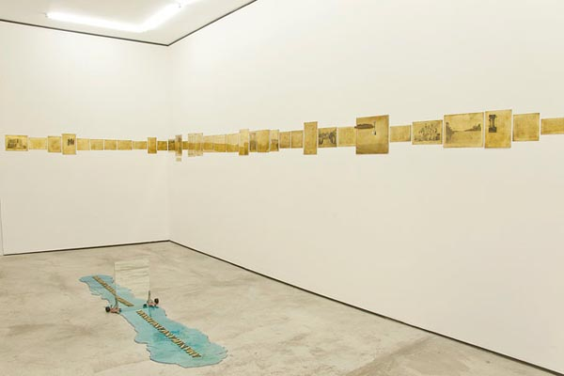

- For the Spring 20/20 exhibition, Camnitzer presents two works, separated by forty years in the artist’s career, where disorientation plays a central role in the viewer experience. The Shift of the Center of the Earth (1975) and Cardinal Points (2015) each take up a single room with interventions in space that pose questions about location, orientation, and power.

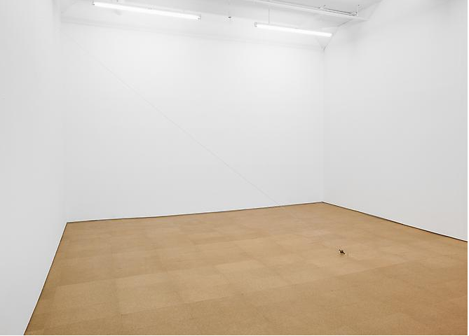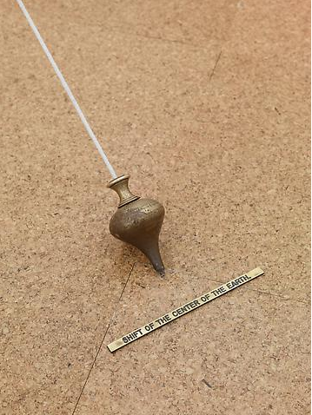

The Shift of the Center of the Earth was included in an exhibition at the Gallery in 2012, the following text and the images above are from the following link: http://www.alexandergray.com/exhibitions/2012-09-12_luis-camnitzer/

- Disorientation plays a central role in the viewer’s experience again with The Shift of the Center of the Earth (1975). The installation is composed of a mason’s plumb suspended from the ceiling, skewed at an angle, seemingly defying natural laws of gravity. This repurposed tool—a trusted guide to our geographic or physical center—leads us astray; Camnitzer’s manipulation of the plumb leaves us doubting which way is down. Here too, Camnitzer questions the role of an individual in our social and political worlds, as well as our psychological: who determines location, myself or the world around me? Camnitzer’s Duchampian gesture–repositioning a found object–certainly addresses the realignment of global politics and capital.

